**Developer Environment Setup Documentation**

1. **Operating System Installation** Steps and Screenshots of Windows 11 Installation: 1. Download Windows 11: - Visit the official Microsoft website: [Windows 11 Download](https://www.microsoft.com/software-download/windows11). - Download the Windows 11 Installation Assistant. - Run the downloaded file and follow the on-screen instructions to upgrade or install.
2. Window 11:

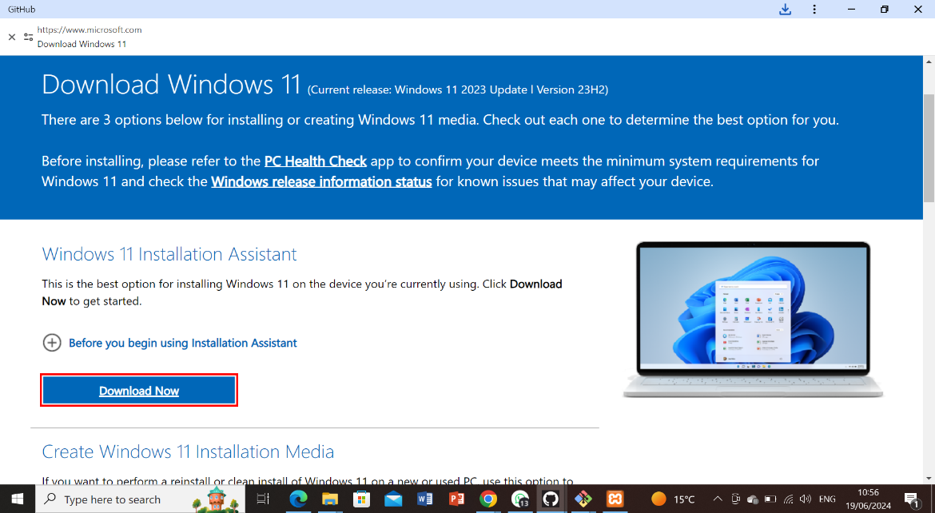

NB; MY WINDOW HAD ISSUES TO INSTALL WINDOW 11

1. **IDE Installation**

1. Download VS Code: - Visit the Visual Studio Code download page: [VS Code Download](https://code.visualstud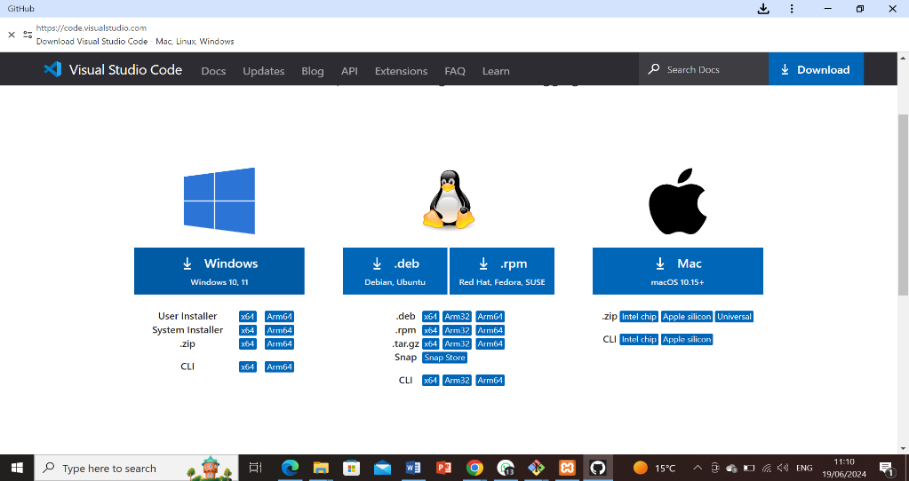io.com/Download).

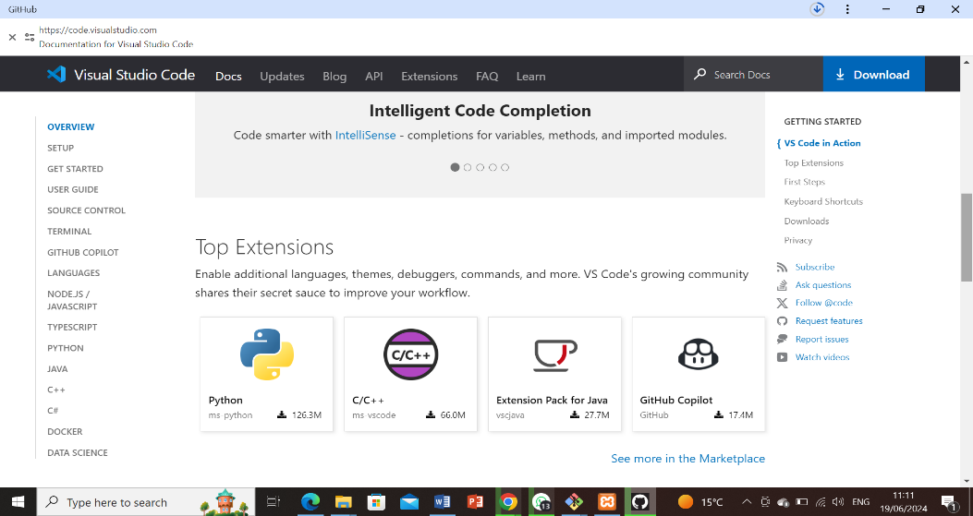

Above is the downloading and the installation process.

1. **First Launch and Setup: - Launch VS Code and install recommended extensions like Python, GitLens, and Docker**.

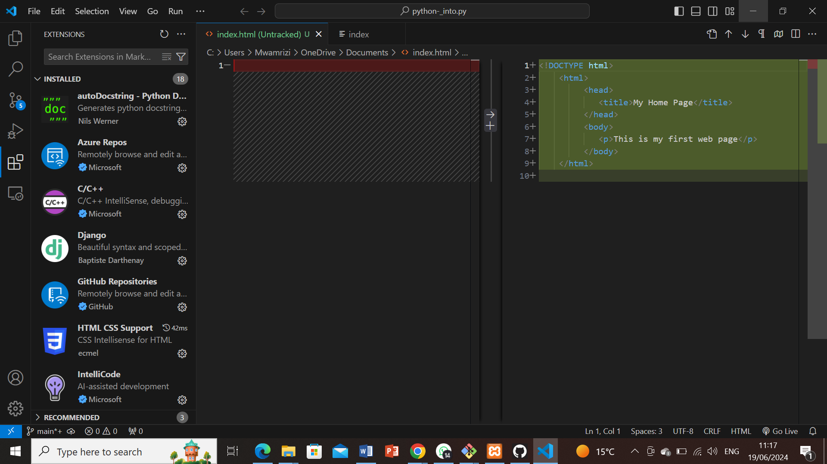

**3. Version Control Setup Steps for Installing Git**, Creating a GitHub Account, Initializing a Repository, and Making the First Commit: 1. Install Git: - Download Git from the official site: [Git Download](https://git-scm.com/downloads). - Run the installer and follow the setup instructions, choosing your preferred options for PATH, line endings, and other settings.

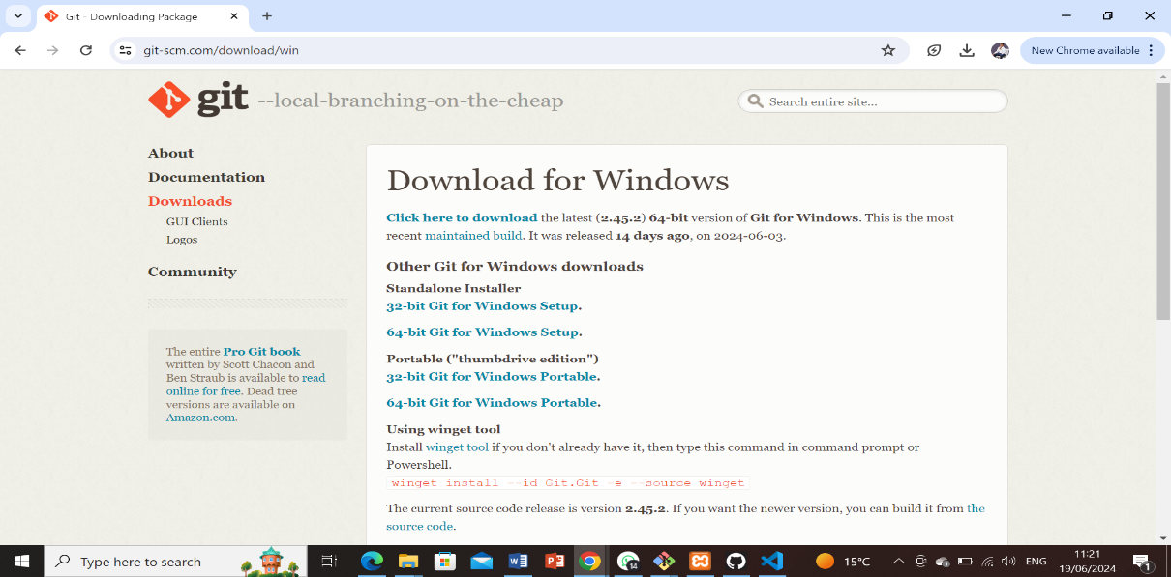

2. **Create a GitHub Account:** - Visit [GitHub](https://github.com) and sign up for a new account if you still need to get one.

I signed to mine with my account.

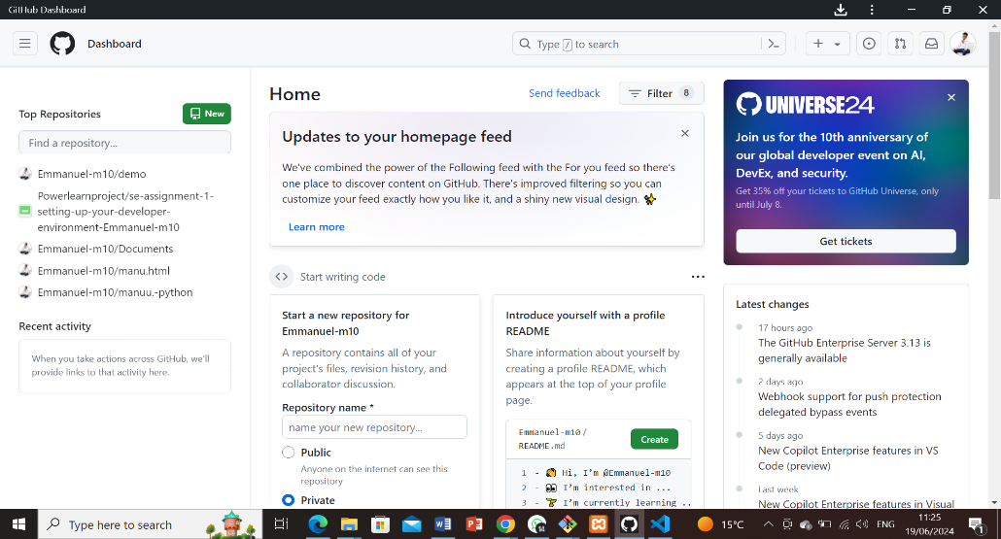

3. **Initialize a Git Repository:** -

Open Git Bash or the terminal in VS Code.

Navigate to your project directory or create a new one:

```bash mkdir my_project cd my_project ``` -

Initialize a Git repository: ```bash git init ``` -

Create a README file: ```bash echo "# My Project" >> README.md ``` - Add the README file to the staging area: ```bash git add README.md ``` - Commit the changes: ```bash git commit -m "Initial commit"

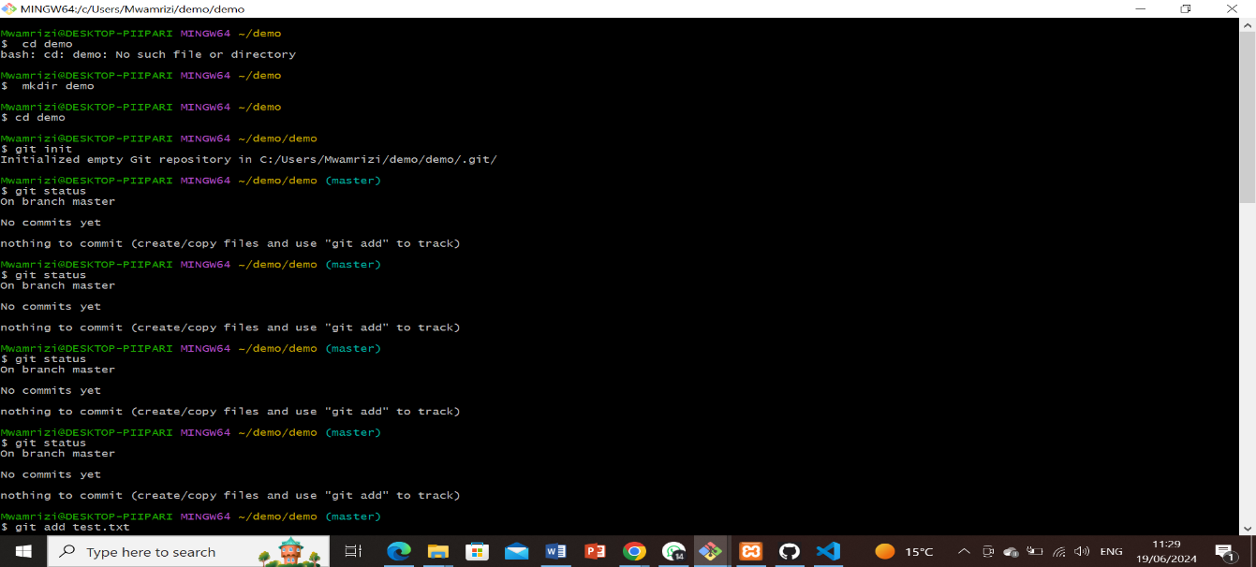

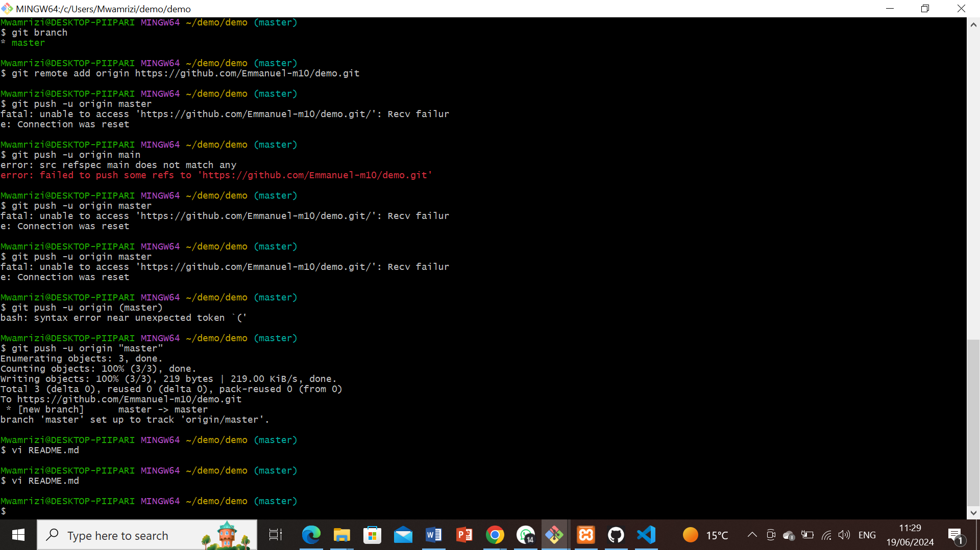

1. **Programming Languages and Runtimes.**

Steps for Installing Python: 1. Download Python: - Visit the official Python website: [Python Download](https://www.python.org/downloads/). - Download the latest version of Python for Windows.

.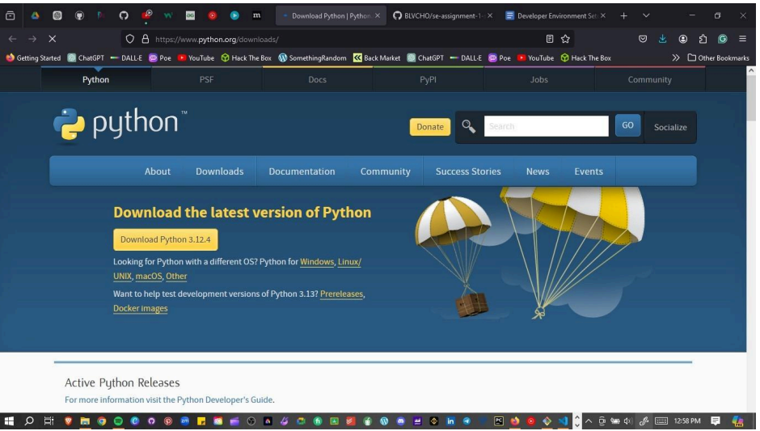

**3. Verify Installation:** - Open Command Prompt and type:

```bash python --version ``` -

Verify pip installation:

```bash pip –version.

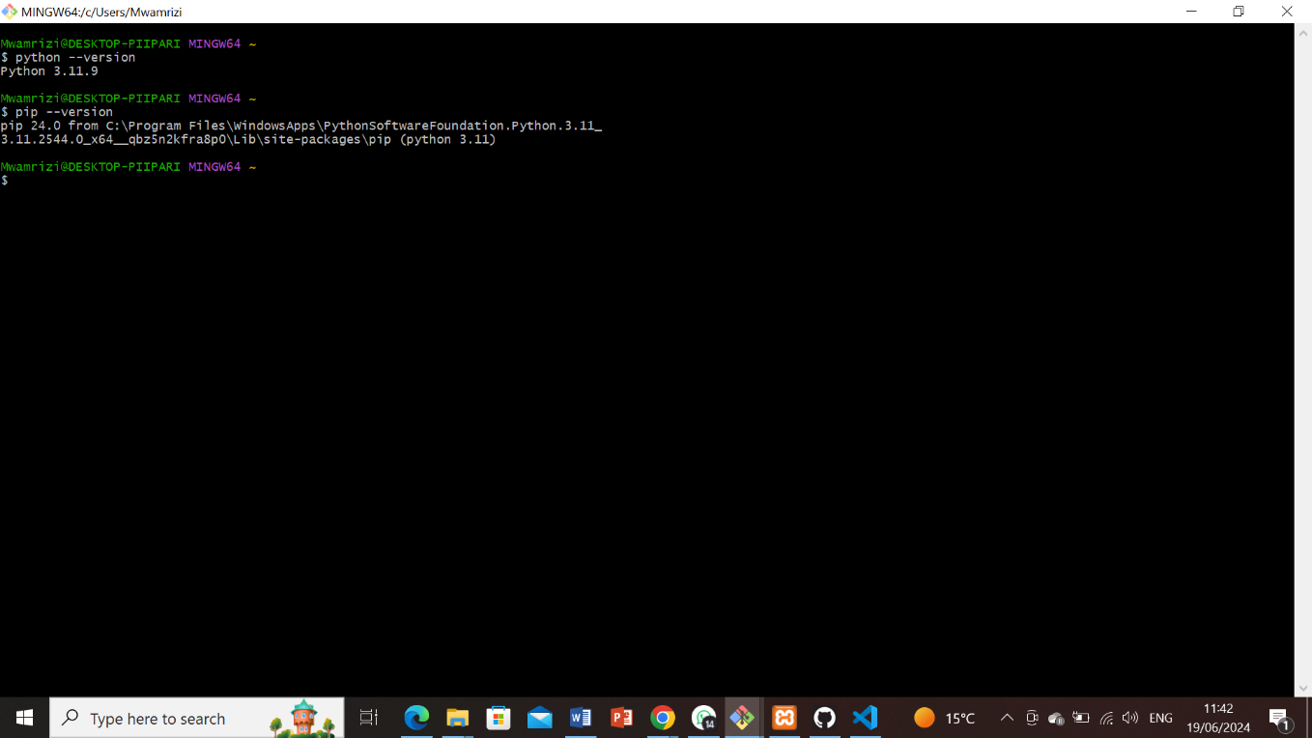

**6.Verify Installation of MySQL**: - Open MySQL Workbench or MySQL Shell and connect to your MySQL server.

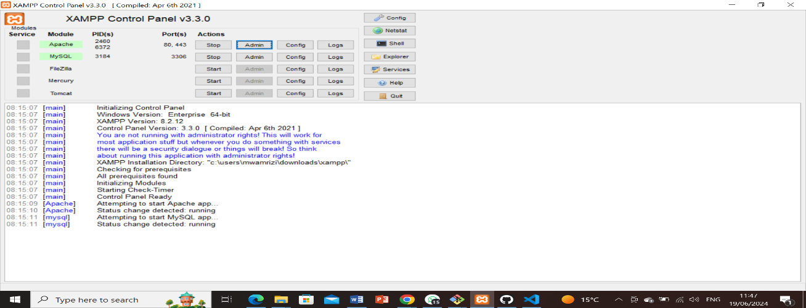

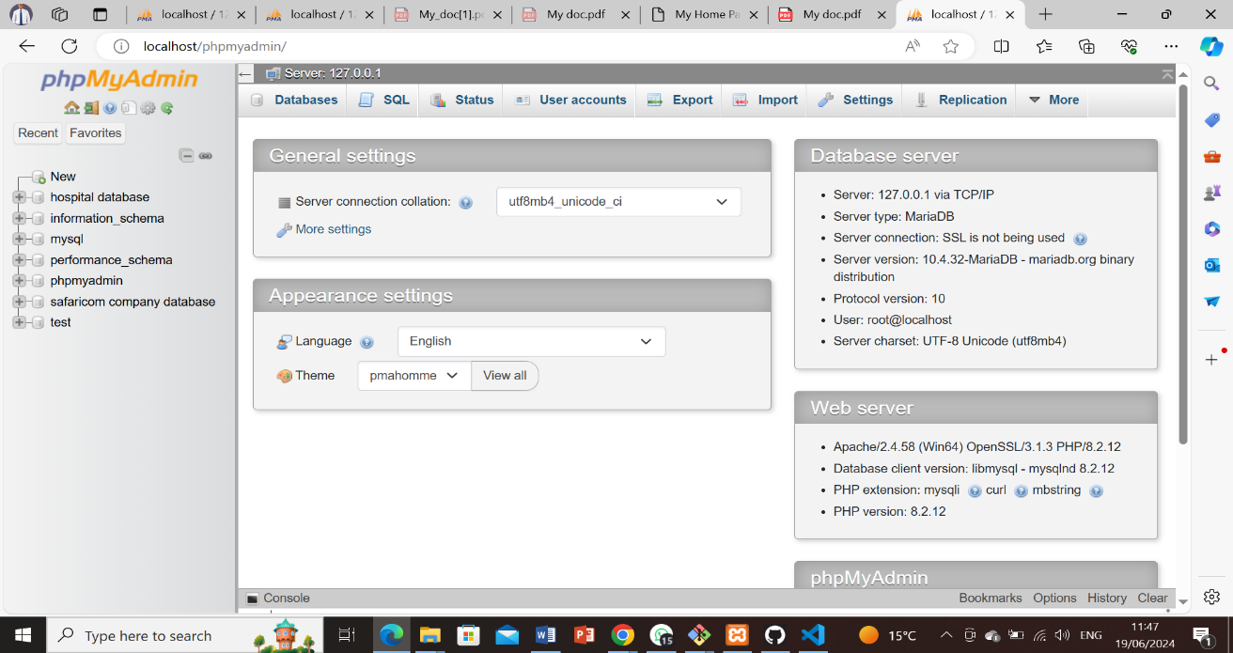

**8. Extensions and Plugins List of Installed Extensions for VS Code**: 1. Install Extensions:

- Open VS Code. - Go to the Extensions view (`Ctrl+Shift+X`). - Search for and install the following extensions:

- Python

- GitLens — Git supercharged

- Docker

- Prettier

- Code formatter

- ESLint

- MySQL

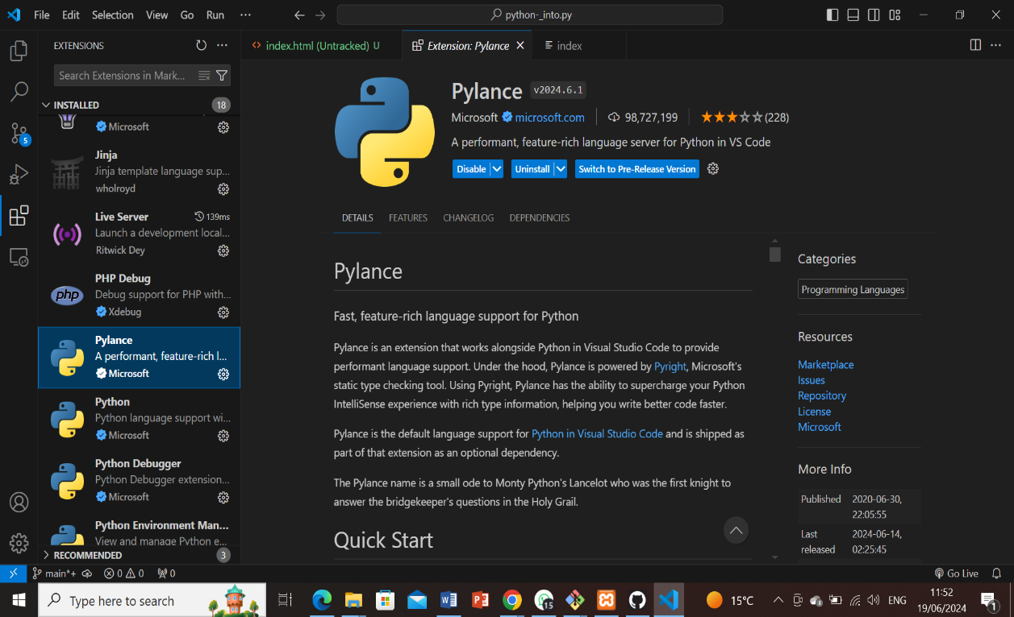

**9. Challenges and Solutions:**

1. Challenge: Installing MySQL and Configuring the Root Password.

- Solution: Followed a step-by-step tutorial and used the official MySQL documentation for troubleshooting.

2. Challenge: Initializing a Git Repository and Making the First Commit.

- Solution: Used Git documentation and GitHub guides to understand the commands and workflow